ATOMS
Use the glossary on page 275 of your textbook to help you write definitions for the following words:-
Word | Definition
Nucleus

Proton

Neutron

Electron

Electron Cloud

Atomic Number

Mass Number

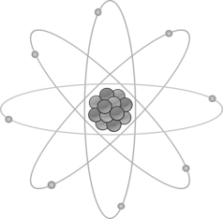

Use page 268 of your textbook to help you, draw a diagram of an atom. Label the following parts:-
- Nucleus
- Protons
- Neutrons
- Electrons
- Electron cloud

Match the subatomic particle to its correct charge:-
PROTONS | Neutral (no charge)
NEUTRONS | Negative -1
ELECTRONS | Positive +1

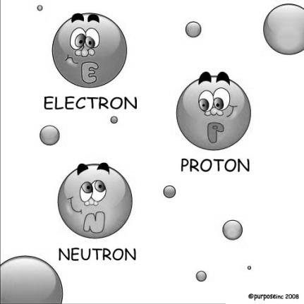

Use page 268 & 269 of your text book to help you answer true or false to the following statements:-
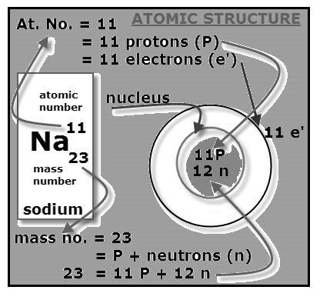
Statement | T or F
- The element sodium is represented by the symbol Na.
- The mass number for Na is 23.
- The atomic number for Na is 23.
- The number of protons is the same as the atomic number.
- There are 12 protons in sodium.
- The number of neutrons is the mass number plus the atomic number.
- There are 12 neutrons in sodium.
- The number of electrons is always one more than the number of protons.
- There are 12 electrons in sodium.
- Protons plus neutrons equals the mass number.

Complete the following table:-
Element | Symbol | Atomic Number | Mass Number | Number of Protons | Number of Neutrons | Number of Electrons
Oxygen |  | 8 | 16
Calcium |  | 20 | 41
Copper |  | 29 | 64



